**Part VIII: Chapter 8: Hypothesis Tests**

**Task 1: Sort data according to position and delete the lieutenant data, then sort according to race and select and move the data for white candidates to new columns on the right. Construct a side-by-side boxplot for mean combined scores of white candidates versus minority candidates and insert below.**

**What does examination of this boxplot suggest about the difference in exam scores between white and minority candidates for promotion to captain?**

**Task 2: Examine the claim that the mean score on this exam is lower than 74.11 for the minority candidates for the captain position.**

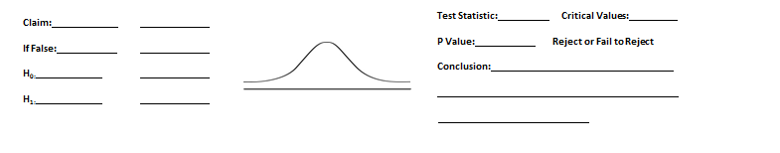

* **If the mean score for white candidates in New Haven is 74.11, what conclusions can we draw from our hypothesis test?**
* **Which procedure, a visual examination of a boxplot or a formal hypothesis test, is more valid proof of the idea that white candidates have a higher mean score?**

**Task 3: Use this data and a .05 significance level to test the claim that less than 58% of the minority candidates (Black and Hispanic candidates grouped together) pass the lieutenants exam.**

